Project Planning

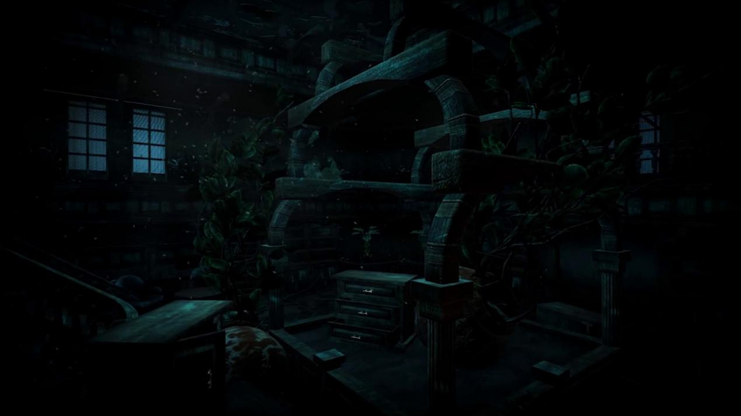

|  |  |
| --- | --- |
| Project name： | Horror Castle——3D chamber escape |
| Group name： | The truth is false |

2020. 6. 1

(Written by Jufeng Li/group leader)

Catalogue

1.Summary of the game 2

1.1 Game Name 2

1.2 Game Introduction 2

1.3 Game Type 3

1.4 Game Playability 3

1.5 Previous Research 4

1.5.1 Product Superiority 4

1.5.2 Target User 5

2.Game Design 5

2.1 Game Backglevel 6

2.2 Game Flow Design 6

2.3 Level Design 6

2.4 Scene Design 9

2.5 Text Design 10

2.6 Props Design 16

2.7 Sound Design 19

2.8 UI design 21

3.Game development 25

3.1 Scene building 25

3.2 Unity development 32

3.2.1 level control 32

3.2.2 Backpack control 33

3.2.3Other logic 35

3.2.4 UI control 38

# 1.Summary of the game

## 1.1 Game Name

Horror Castle

## 1.2 Game Introduction

《Horror Castle》Is a 3D simulation adventure terminal game based on the independent creative development of Unity engine, developed by the truth is false team cooperation.

At the beginning of the game, the character who loves decryption reasoning game from a desolate strange castle wakes up, with all things of his missing. The hero needs to find all the clues, uncover layers of fog, and escape the castle.

This game is the first perspective game, which is unable to switch the perspective, with a total of eight levels.

## 1.3 Game Type

3D simulation adventure horror standalone game

## 1.4 Game Playability

**Level design with varying difficulty**

The game contains a total of eight levels. Each level of the plot is linked with another level. The level of difficulty also has a stepwise change.

In the password cracking, the first level of the password is directly given, the third level requires the player to get the slip of the password in reverse, and add the other two slip of the password.

The seventh level requires the help of prop magnifying glass to see the password prompt; the password prompt has changed from text to graphics.

In the search for the key, the first level players directly find the key, the eighth level needs to be found by the key fragments to synthesize, and one of the key fragments is still in the second level.

**Variety of gameplay design**

In addition to the general intelligence of decryption crack password, the game is also embedded in the puzzle and other small games, which is also the player’s access to password.

There are flashlights, kerosene lamps, fireplaces and other props that players can choose to adjust the brightness

**Realistic visual experience**

This game is a 3D game, more three-dimensional and realistic than 2D games, can better simulate the effect of escape chamber.

The first perspective of the game enhances the player's sense of substitution

## 1.5 Previous Research

### 1.5.1 Product Superiority

**Market Requirement**

Escape from the Chamber of Secrets is a live action puzzle adventure game that first appeared in 2006 and was popularized in the Chinese mainland from 2012 to 2013.

In recent years, Chamber of Secrets Escape Marine has achieved rapid development. In 2018, the scale of Chamber of Secrets Escape industry reached 5 billion yuan, and in 2019, it doubled.

In recent years, China's secret room industry has developed very fast. The number of stores in China's secret room industry increased from 7,331 in 2016 to 10,683 in 2018, with a compound growth rate of 20.7%.

The number of Chamber of Secrets themes increased from 4,037 in 2016 to 9,736 in 2018, representing a compound growth rate of 55.3 percent.

At present, the Chamber of Secrets escape industry is in a stage of rapid development, the existing products on the market cannot meet the needs of users.

Room of Secrets Escaping stores usually involves long waiting in line

**Product Features**

High input-output ratio.

Compared with ordinary 2D games, this game is more realistic and allows players to have a more immersive feeling. Compared with physical stores, the cost of operation and maintenance is greatly reduced.

Low limit of use.

The game only needs to download the client to be used, and the configuration requirements of the computer are not high. It avoids the trouble of queuing in the physical store, and avoids the device restrictions of the immersive game.

At the same time, brick-and-mortar stores are mostly team games, this game does not need team cooperation, but can be played alone

### 1.5.2 Target User

Age：15-30

Occupation：High school students, college students, young civil servants, white-collar workers

Characteristics：Young, open to new things, adventurous and deciphering

# 2.Game Design

## 2.1 Game Backglevel

You open your eyes and you look at the décor, recalling that you're investigating a deserted, weird old castle.

You are a decryption reasoning game enthusiasts, keen on a variety of mysterious supernatural events.

One day, you pass through a small frontier town and hear people talking about an old castle in the suburbs.

They said the old castle had stood for centuries. The bleak and eerie appearance attracted many curious explorers, but none of the people who went into the castle to explore its mysteries ever saw them appear again.

The old people said that there was once a ghost who died unjustly here. He killed all the invaders. He ate their blood for water and their bodies for food, and buried their bones in the glevel, and their souls had no place to go.

This kind of narration makes you eager to try out the curious things you don't know.

You prepare the equipment and food, and in the evening, you open the door of the mysterious old castle.

You explore all the unlocked rooms and find nothing. You are back in the lobby on the first floor.

At this moment, there is a sharp pain in the back of your head, and just before you lose consciousness, you think you hear someone's eerie laugh, and then your consciousness sinks into darkness.

## 2.2 Game Flow Design

## 2.3 Level Design

There are eight levels in total, each of which is of different difficulty, and the difficulty is not set in a gradient, but in the middle some levels are simply overdone.

Most of the levels are independent of each other. In addition to connecting the game through the story, the second level and the last level are also connected to create a level of uncertain difficulty, which makes the game more connected and playable.

Here is the level setup in detail:：

**Interface of the start of the game**

The player can click Game Settings on the home page to choose to turn off the sound effect, click Game Help to understand the gameplay, and click Start to enter the first trapped room.

**Level 1**

The player finds a key, a screwdriver and four cards marked with numbers and directions, uses the screwdriver to repair the password lock of the door, according to the card prompts to rotate the button on the electronic lock of the door, the player can open the door lock and leave the room, use the key just found to open the door of the second room, into the next level.

**Level 2**

The player smashes the vase with the fire extinguisher to get the crowbar, which pries open the door of the box to get a key shard, finds a key near the table leg, and uses the key to open the door and enter the next level

**Level 3**

The player firstly gets the password 74 from the photos on the table and the bookcase, enters the password 74 in the bookcase to get the key, opens the safe to get the slip with the password (4256), enters the password on the electronic lock at the door, and the password 476524 for the wooden cabinet password lock

**Level 4**

After coming out of the room of the third level, the cloister is found to have a boundary. A mirror could be seen on the table near my sister. After the mirror is built, the player will be sent to the first room.

Player and then finds a mirror in the bedside table of the first room, through this mirror player can be then transferred back to the first room, and find that there is a clock on the wall of the first room, pointing to two points, the first level and second corridor and the three rooms out back wall surface has the same clock, use the mouse the rotating mirror pointing at two o 'clock and keep 3 seconds, the mirror will be broken after receive the green light, then enchantment will disappear, the player can leave.

**Level 5**

The player gets lighter from the corridor cabinet drawer, then from left to right in turn lights up three candles, after which a pendulum moves off the ceiling. In addition, the player should get another pendulum from another cabinet drawer. Behind on the wall painting is a pair of shoes, from which the player is able to find a key, using which to open the cupboard door of the clock on floor, then put the two pendulums in the right place in to the clock. At this time, the player can the third drawer of the cabinet which he encounters first, from which to obtain a crowbar, pries the wood on the door with the crowbar. Eventually the player can leave and go to the stairs to the first floor.

**Level 6**

The player comes to the stairwell to find that there is a boundary here, in the corridor to find four cards, with four cards to create a complete picture, according to the instructions in the picture to change the order of the picture placed on the wall, according to the paper to adjust the rearrangement can eliminate the boundary downstairs。

**Level 7**

The player comes to the door downstairs, and finds that there is actually a wall instead of a door.

Then the player comes to the hall, from the box to get the needle, magnifying glass; from the shelf to puzzle the painting on the wall assembled into a complete picture; then frame will drop down to reveal a black circle, through a magnifying glass to observe to see password pattern, through the password before opening pattern with needle box, get the key.

When the player gets to the safe, put the key in the keyhole below the handle. When you put the pin in the top keyhole, the safe will open. When you open the keyhole, the wood in the fireplace in the hall will automatically ignite, and the door of the castle will appear and start the next level

**Level 8**

Find two key fragments and a bottle of glue in the cloister on the second floor at the side of the gate. Stick these two fragments together with the fragments obtained in the second level to get a complete key. Open the gate of the castle and escape

## 2.4 Scene Design

**Overall Thinking**

* Based on the setting of the game backglevel, I decided to design the game scene alevel the theme of horror and escape from the secret room.
* In order to achieve the effect of escape from the mystery room, choose to find or build a closed castle or villa.
* In order to achieve a frightening atmosphere, in addition to the post-production sound rendering, I decided to create a frightening atmosphere through the indoor model style and lighting.
* Since there are eight levels in the game, there needs to be plenty of space for the design of the level

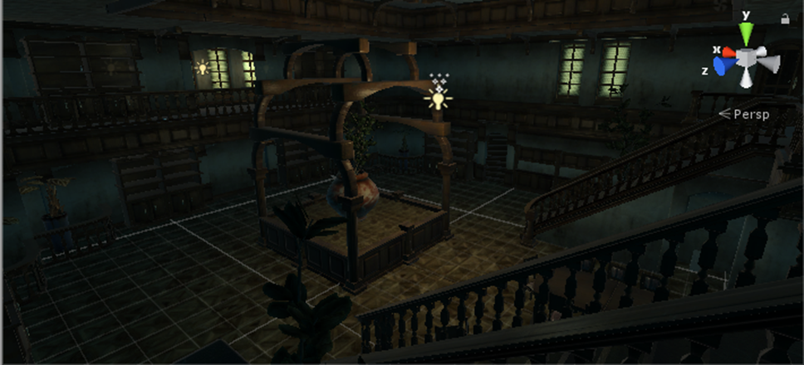

Scene of the Hall

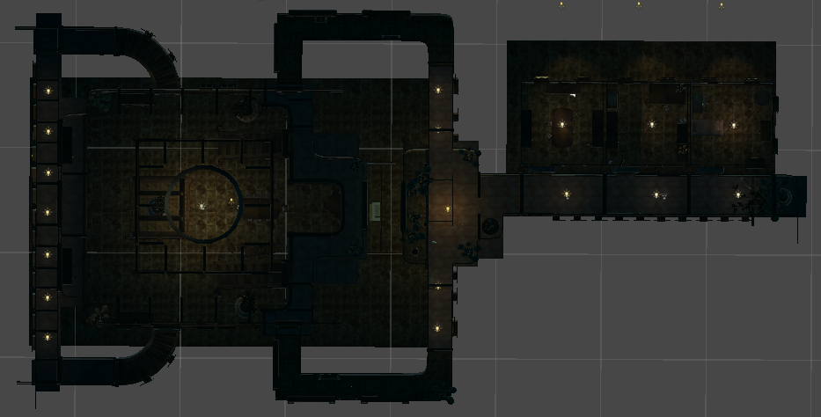

Scene Plan

## 2.5 Text Design

**Player File**

You're a fan of all kinds of mysterious and paranormal events. You joined a group of decrypting enthusiasts at your university, and you love to explore places with paranormal legends on your travels.

Because of your special constitution, you are more likely to encounter strange events that are hard to explain than others, so you can learn a lot of stories that are hidden from the perspective of ordinary people.

**Ghost File**

The castle was once the home of a large family, who believed in an evil god and apparently took in passersby or homeless people, but in fact kept them under house arrest and offered them as sacrifices to the true god.

She had seen her friends brought to the altar and set alight, and then she too had to be sacrificed.

She and here all the victims of anger and resentment into the castle floating in the ghost.

It happened almost every day in the castle that a door key disappeared or an item suddenly changed its place.

People in the family eventually died for a variety of reasons.

**Level 1**

Start ：

You walk alevel the house and realize that you are locked in the same room with all your belongings missing. From the obvious hunger in your abdomen, you assume that you have been fainting for a long time. In a word... Let's get out of here

Card ：

A card with numbers and directions. The paper was yellowed, and there was still some dust on it. Maybe it's a sign to get out.

Screwdriver ：

A screwdriver. It doesn't look quite the same as the objects alevel it. It looks brand new. Perhaps it was recently placed here by someone.

Key ：

A very small key. It doesn't look like the key to the door... Look for other clues in this old castle.

Coded lock ：

The electronic lock on the door has four knobs. Will random movements trigger any mechanism in the house... I'd rather not touch it。

Pass：

Come out. Go to the next room... Perhaps I will learn the secrets of the castle in my escape.

**Level 2**

Start ：

The second room……

Extinguisher ：

A fire extinguisher heavily dappled with ash. Does this still work?

Crowbar :

A heavy crowbar can be used to open the box

Key ：

According to the protocol, this should be the key to the door......

A piece of a key ：

A piece of a key, and there are other parts of it scattered elsewhere.

Pass ：

Will that female ghost appear again...... A little nervous

**Level 3**

Start ：

The rooms are dark and dank... It's no place for a man to stay.

Photo frame ：

Inside the frame was a piece of paper with the number 7 written on it

A note with figures ：

A tattered piece of paper with "4256" written on it

A key ：

A key. It doesn't look like a house key

A piece of a key ：

A piece of a key, and there are other parts of it scattered elsewhere.

Pass ：

I finally got out of my room...Oh, don't get too excited, I still have a lot of puzzles waiting for me.

**Level 4**

Start ：

Trapped... You have to figure out how to break this barrier.

A piece of a mirror ：

A piece of mirror with a sharp edge. Be careful of cutting your finger.

Pass ：

I'm so hungry... I don't know where the backpack went... alas.

**Level 5**

Start ：

This still seems to be a room on the second floor. Try to get downstairs.

Lighter ：

An old blue cigarette lighter that felt like it was running out of gas.

Pendulum ：

One of the pendulums on the glevel.

Key ：

Hidden in the shoe was a key that did not appear to be the key to the door.

Crowbar ：

An old crowbar used to pry boards open.

Pass ：

I'll be ready to go downstairs in a minute. The lobby should be a little safer than upstairs......

**Level 6**

Start：

There were pictures hanging on the walls...

Maybe this has something to do with breaking the boundary.

Jigsaw：

A fragment of a painting, find other parts should be able to see the full picture.

Pass：

The boundary is gone...Finally, I can go downstairs. This old castle is really uncomfortable.

**Level 7**

Start：

Here we are again in the hall. We are about to go out.

I hope nothing strange will happen again.

Needle：

A needle stuck in a box may prick your finger if you don't care.

Magnifying glass：

A magnifying glass. It looks old, but it still works.

tweezers：

A pair of tweezers. I don't know what it can be used for.

Key：

It was a very small key that didn't look like the key to the room door.

Handle：

A handle that had fallen on the floor. It felt like it had come off some device.

Pass：

I feel like it's almost time to go out, this house is just suffocating......

**Level 8**

Start：

I feel like I haven't had a breath of fresh air for a long time.

Is it day or night outside the gate...

A piece of a key：

A piece of a key, and there should be other parts scattered elsewhere.

Glue：

A small bottle of glue. There is not much left in the bottle, use it with care.

Pass：

It's time to leave. It's been a weird and scary trip.

## 2.6 Props Design

In each level, players need to obtain different items to solve the problems encountered in each level, and finally achieve the goal of escaping the castle.

**Level 1**

The main items required for the level are: two photos with numbers and directions, two cards with numbers and directions, a screwdriver, a door with a combination lock, and a key.

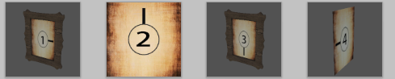

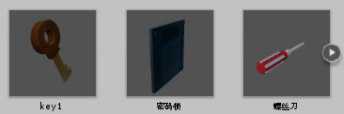

**Level 2**

The main items required for the level are: fire extinguishers, vases, boxes, vases, crowbars, keys, and key fragments

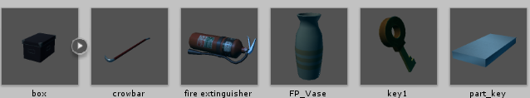

**Level 3**

The main items required for the level are: two numbered stand-up photos, a numbered card, a locker with a combination lock, a safe, a door with a combination lock, and a key

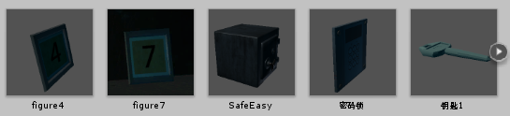

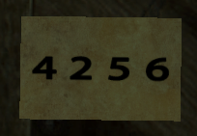

**Level 4**

The fourth scene covers the first three scenes, the main items required for the level are: three clocks pointing to two o 'clock, two mirrors

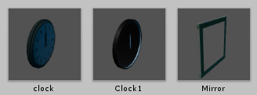

**Level 5**

The main items required for the level are: a wooden board (to seal the stair door), a crowbar, two cabinets, a floor clock, a candle, shoes, a lighter, a pendulum, and keys

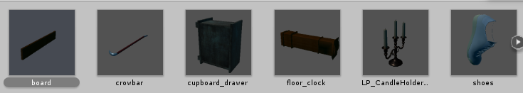

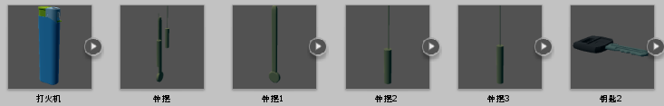

**Level 6**

The main items required for the level are: five photos, four puzzle cards

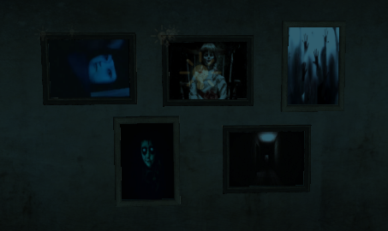

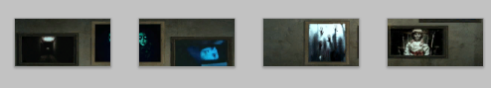

**Level 7**

The main items required for the level are: a needle, a box with a combination lock, a magnifying glass, a painting for puzzles, a code on the wall, a safe, a fireplace, firewood, a key, and a door

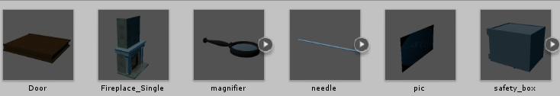

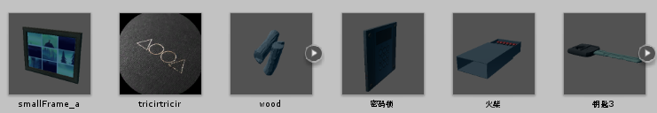

**Level 8**

The main items required for the level are: two pieces of key, glue, and a key

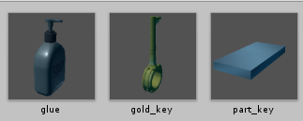

## 2.7 Sound Design

**General Idea**

* + Game sound is mainly divided into four parts, that is, backglevel sound, environmental sound, sound, prompt sound
  + Adapt different sounds for different scenarios, such as different levels opening doors with different sounds
  + Game material from the network, through AU and other software to adjust.

**Sound Types**

|  |  |  |
| --- | --- | --- |
| Classification | Implication | Impact |
| Backglevel music | Backglevel music for the game | Render an atmosphere of horror |
| Environmental sound | The sound produced by the simulated environment is not directly related to the behavior of the protagonist | Render an atmosphere of horror and Have a certain suggestive effect on the plot. |
| Sound of  material object | The sound effects of the environment's are directly related to the protagonist’s behavior | Simulate real scenes |
| Prompt tone | System feedback sound | Operating system feedback |

**summary of Sound effect**

|  |  |
| --- | --- |
| Universal sound | Backglevel music, UI button prompt sound, moving sound of player's footsteps, prompt sound for props |
| first level | The sound of:opening windows,the wind,opening cabinet doors,seeing female ghosts,opening drawers,knobs,password lock error,door opening |
| Second level | The laughter of female ghost, the sound of broken vase, the sound of the door opening (with correct prompts) |
| Third level | The sound of:Button prompt, password lock error report, cabinet door opening,turning door opening,door opening,eliminating barrier, screaming |
| Fourth level | The sound of:turning on the flashlight,traveling through time and space,broken porcelain,the wind,opening door |
| Fifth level | The sound of:opening a drawer,lighting a candle,electricity,a pendulum falling to the glevel,closing the lid of the pendulum,moving the pendulum,breaking and opening the door |
| Sixth level | The sound of:electric current,time moving,eliminating the enchantment |
| Seventh level | The sound of:electric current,lighting a kerosene lamp,opening the safe,burning wood and explosion |
| Eighth level | the sound of opening the door and Synthesizing the key |

## 2.8 UI design

**Simple and soft interface style**

* + Design the UI with white keynote
  + The auxiliary color of gray and the dark red of the disabled button are in line with the gloomy and terrifying atmosphere of the scene
  + Use cloud cover or borderless mode

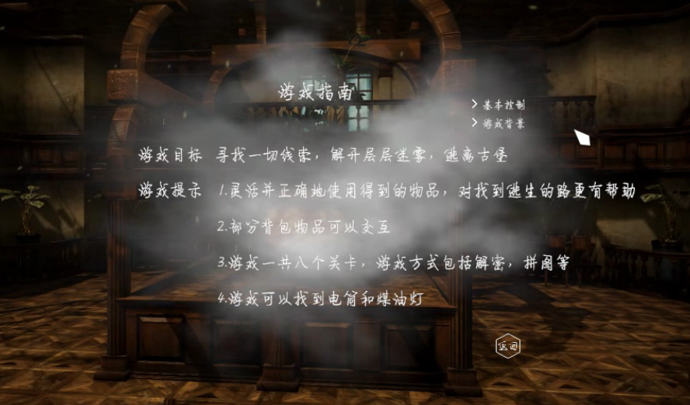

Game help includes game guide, game backglevel, basic control

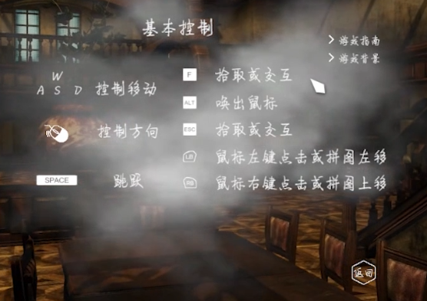

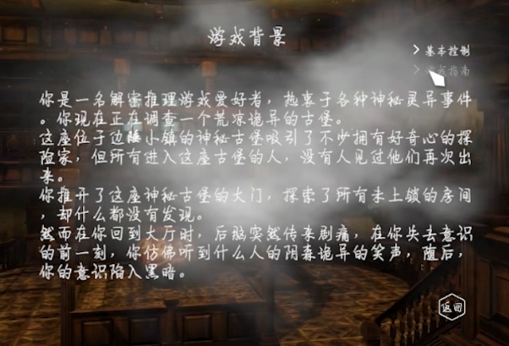

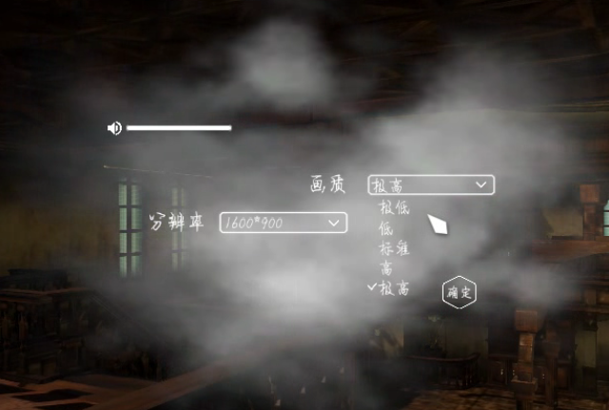

Set the resolution,picture quality, and music control

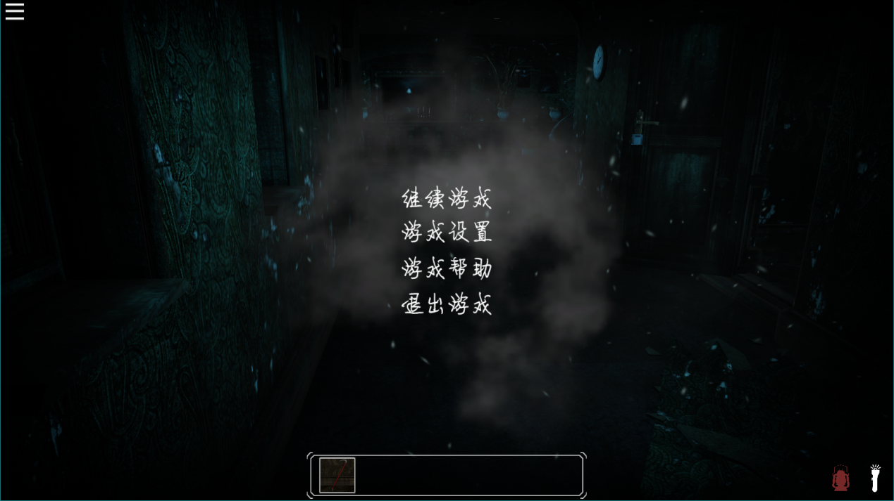

* The upper left corner is the game egg button
* Backpack is In the bottom
* The lower right corner is flashlight and kerosene lamp, and the uncollected display is dark red

**Based on UGUI and animation system design**

* Click effects and interactive effects are achieved through the animation system and UGUI
* Animation effects: fade in and fade out, zoom in and zoom out, pan, typing effect
* UGUI controls the opening and closing of windows, etc.

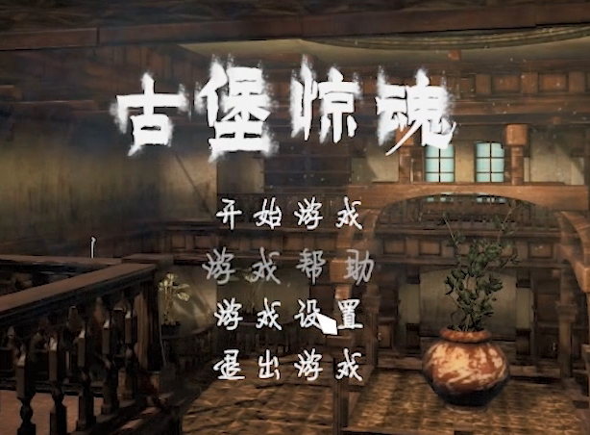

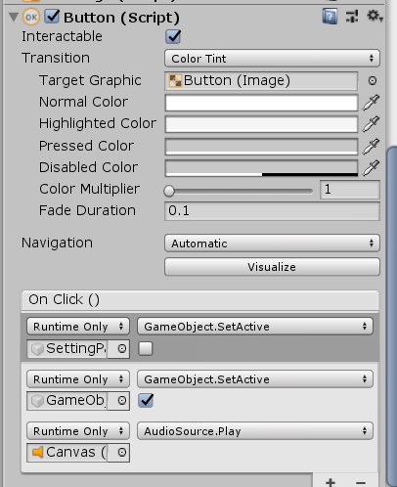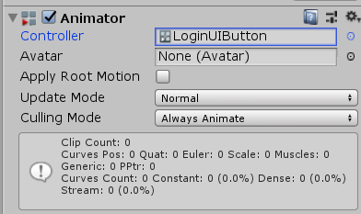

# 3.Game development

## 3.1 Scene building

**First level**

The main items required: two photos with numbers and directions, two cards with numbers and directions, a screwdriver, a door with a code lock, and a key





The overall scene effect and the placement of props are shown in the figure below

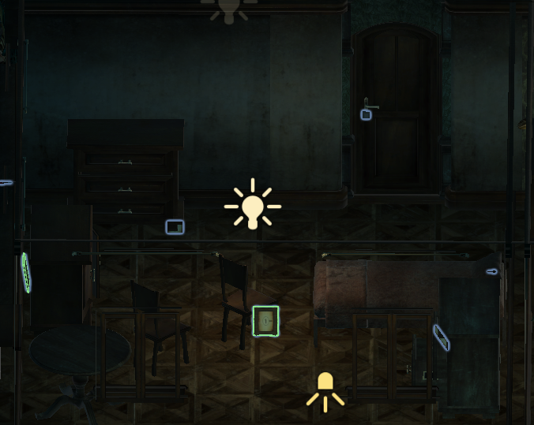

**Second level**

The main items required: fire extinguishers, vases, boxes, vases, crowbars, keys and key fragments



The overall scene effect and the placement of the props are shown in the following figure, where the crowbar is in the vase, and the key fragments are in the box

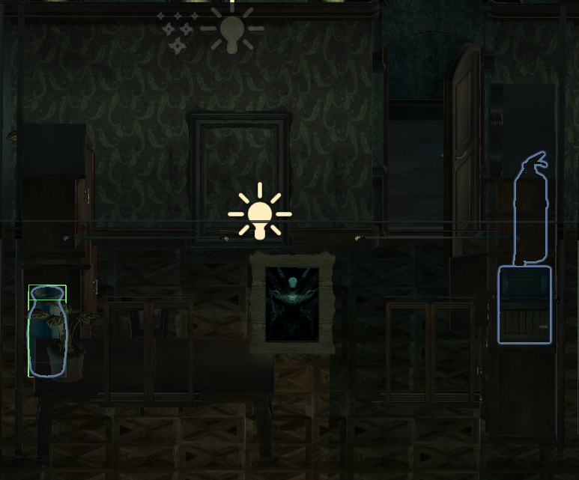

**Third level**

The main items required: two vertical photos with numbers, a card with numbers, a cabinet with a code lock, a safe, a door with a code lock, and a key





The overall scene effect and the placement of props are shown in the figure below

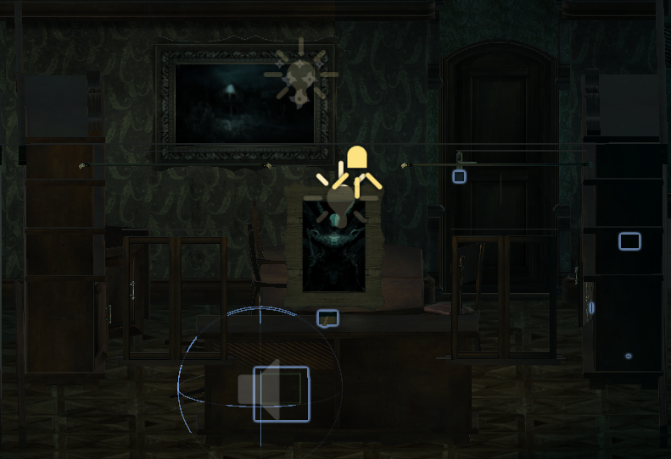

**Fourth level**

The fourth level scene covers the first three levels

The main items required: three clocks pointing to two o'clock, two mirrors



The overall scene effect and the placement of props are shown in the figure below

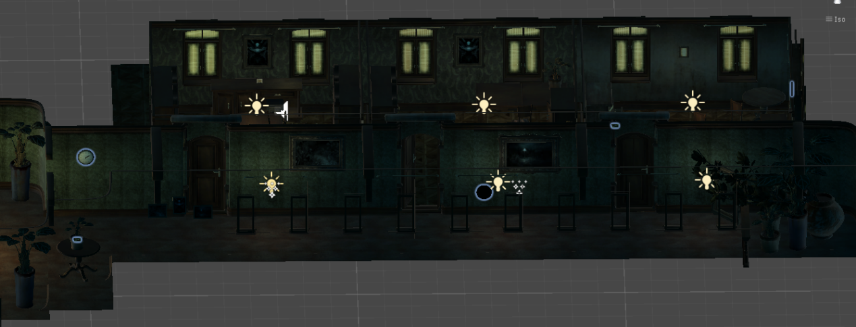

**Fifth level**

The main items required: wooden boards (used to close the stair doors), crowbars, two cabinets, floor-standing clocks, candles, shoes, lighters, pendulums and keys





The overall scene effect and the placement of props are shown in the figure below (red box area)

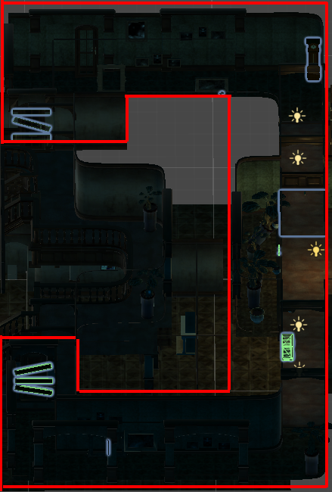

**Sixth level**

The main items required: five photos, four puzzle cards





The overall scene effect and the placement of props are shown in the figure below

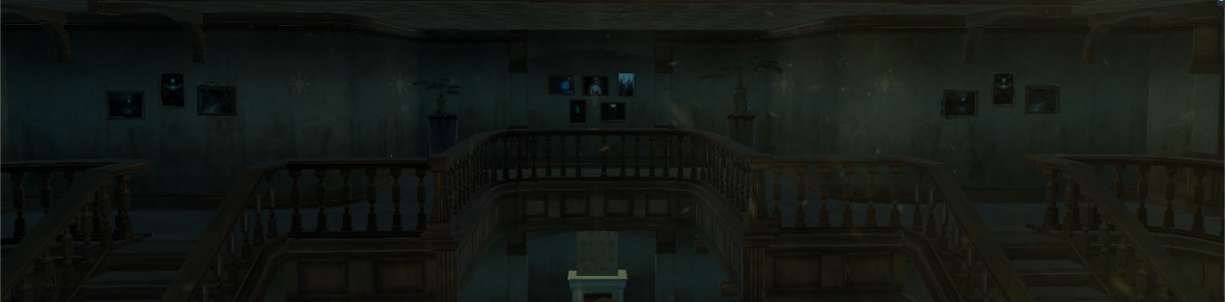

**Seventh level**

The main items required: needles, boxes with code locks, magnifying glasses, oil paintings for puzzles, codes on the walls, safes, fireplaces, firewood, keys, and doors





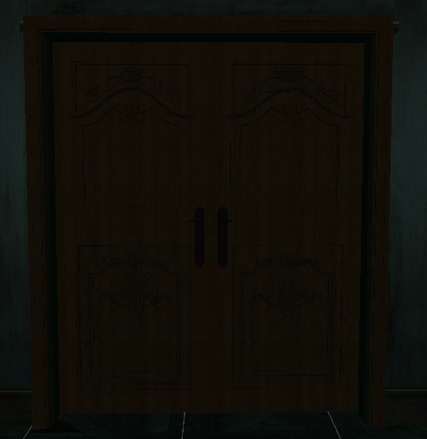

The overall scene effect and the placement of props are shown in the figure below

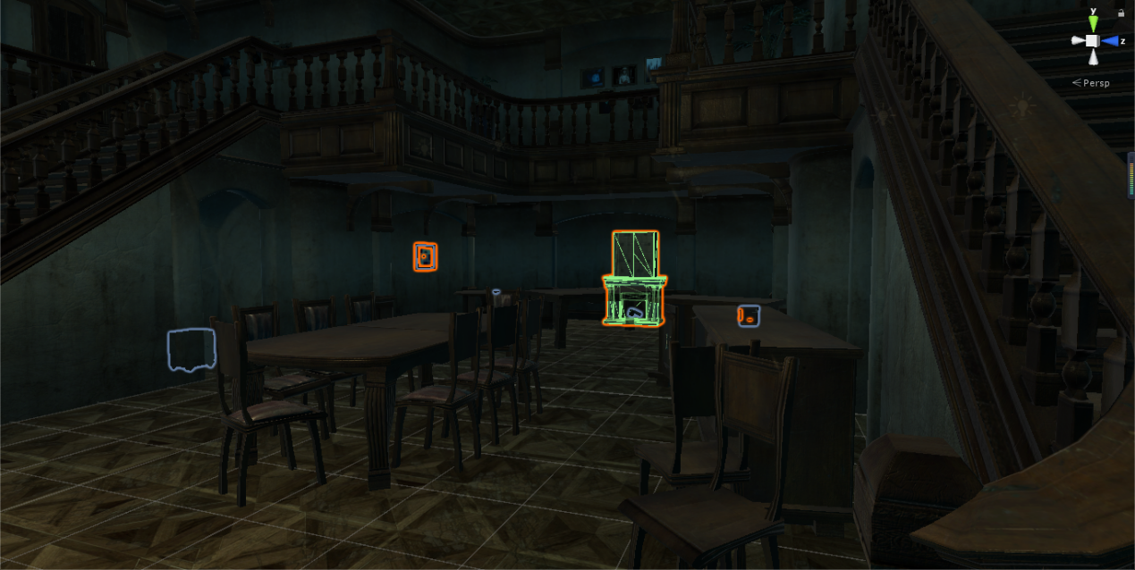

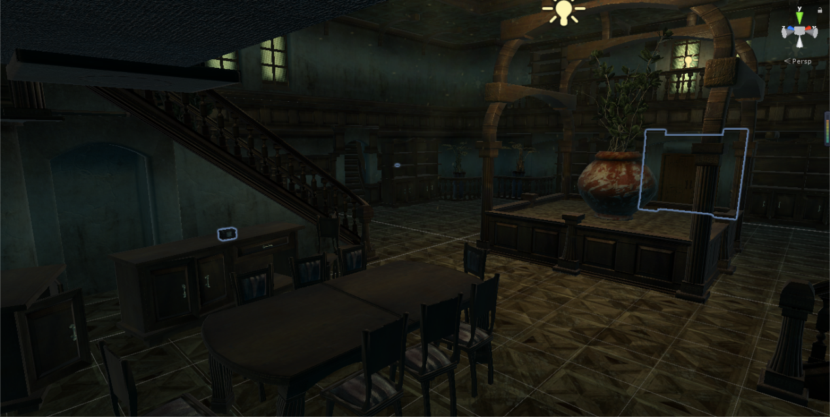

**Eighth level**

The main items required: two pieces of key fragments, glue, keys



The overall scene effect and placement of props are shown in the figure below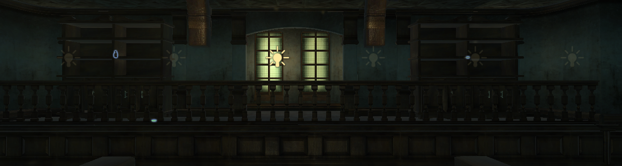

## 3.2 Unity development

## 3.2.1 level control

**Base class:OnFetch**



**Instance function**



（1）Base class framework

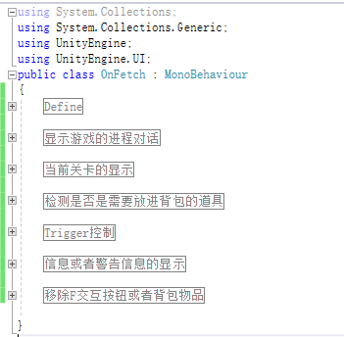

（2）Variable definitions

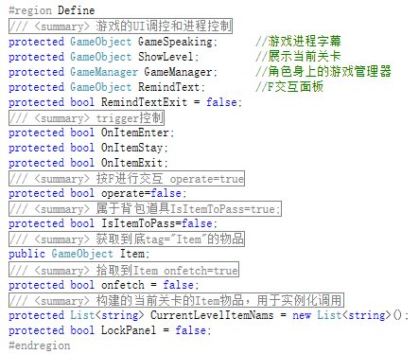

（3）Trigger control

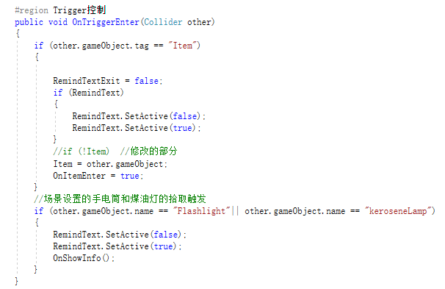

## 3.2.2 Backpack control



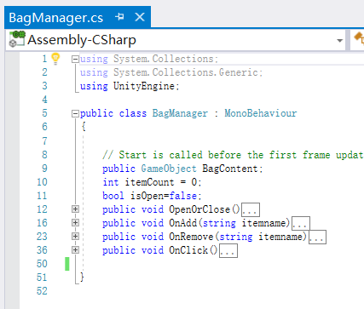

（1）Add item

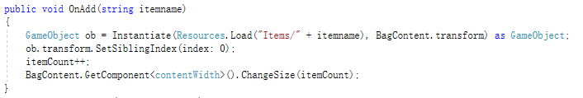

（2）Delete item

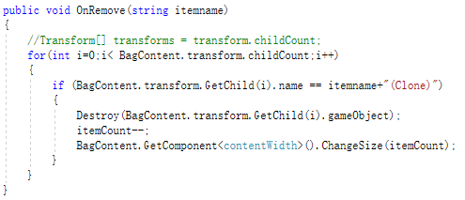

The function contentWidth is called to adjust the length of the backpack in real time to optimize the experience of the backpack

（3）Backpack props display

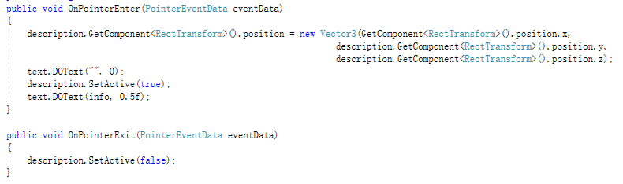

Introduce the Dotween plug-in to make the text display one by one



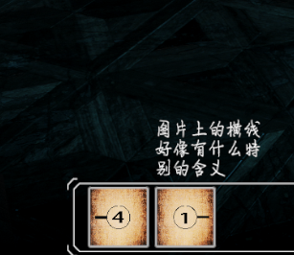

## 3.2.3Other logic

**Password lock logic**：Use image rotation direction judgment and string correspondence



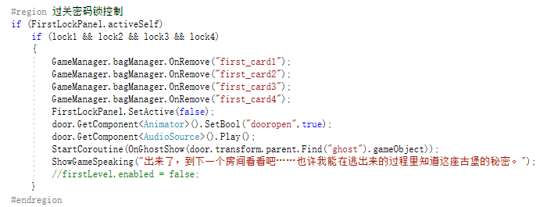

**Puzzle logic**

Canvas jigsaw puzzles are made by changing the SiblingIndex of the picture transform

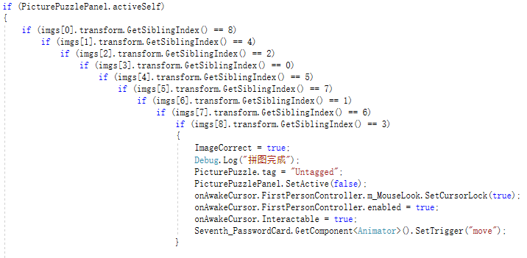

The picture of the scene is judged by the positional relationship

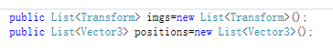

（1）Get the initial position of the picture

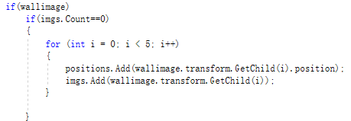

（2）Determine the position relationship

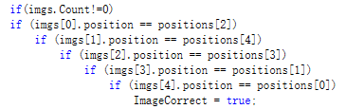

**Mirror rotation**

（The mirror will change rotation when the mouse is moved on the screen）

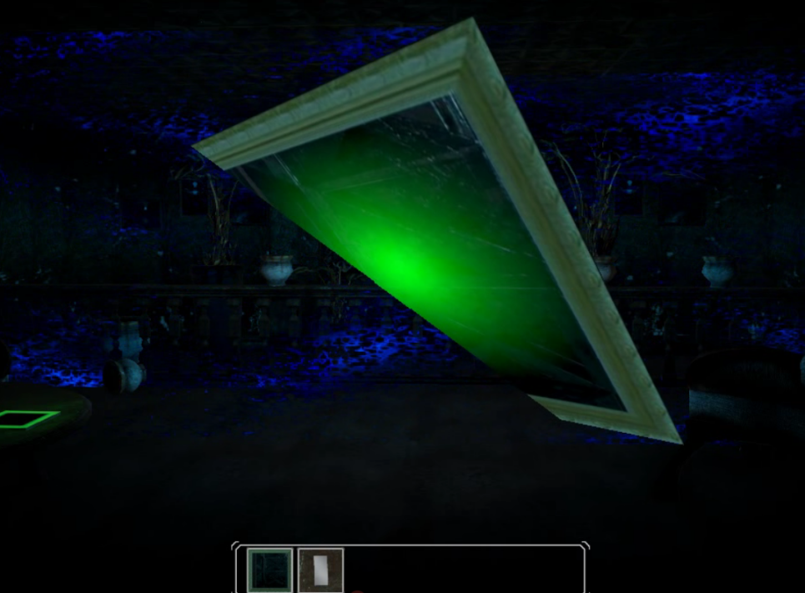

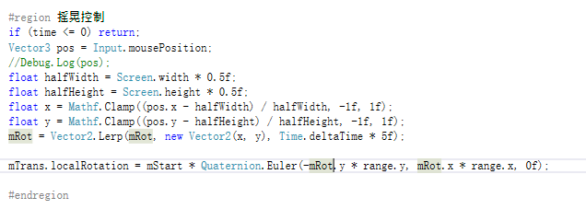

## 3.2.4 UI control

**UGUI interaction**

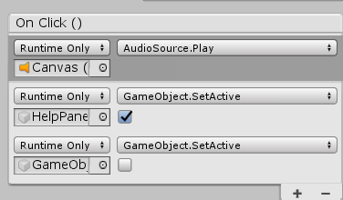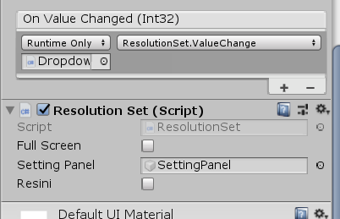

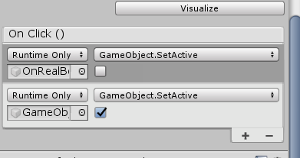

**Code call**



3.Resolution control and image quality control



**Resolution control**

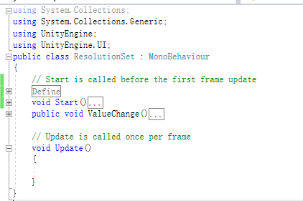

Get computer resolution and add it to dropdown

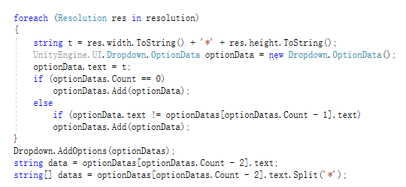

According to the original setting, it is limited by 16:9

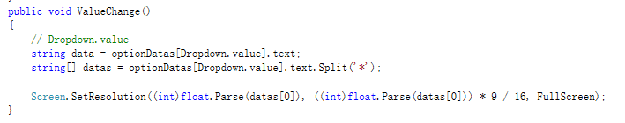

**Picture quality control**

